**Rebeca Matewanga Maria Kamalandua**

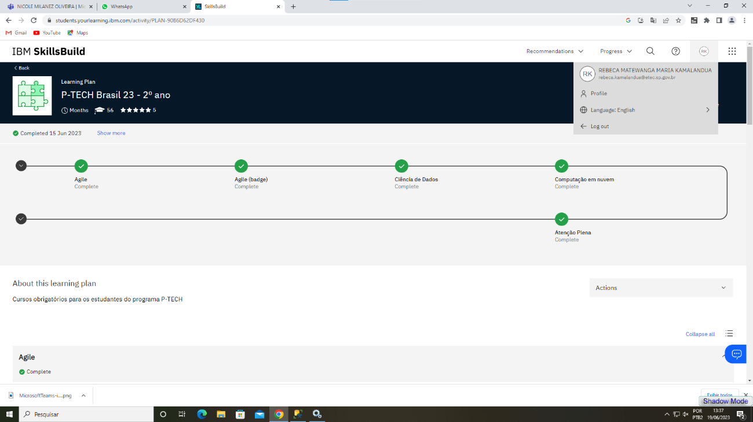Pagina inicial P-TECH Brasil 23- 2°ano

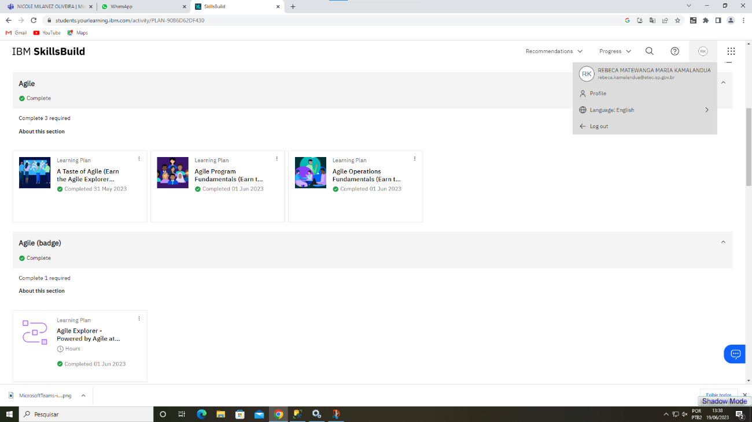Cursos Agile e Agile (badge)

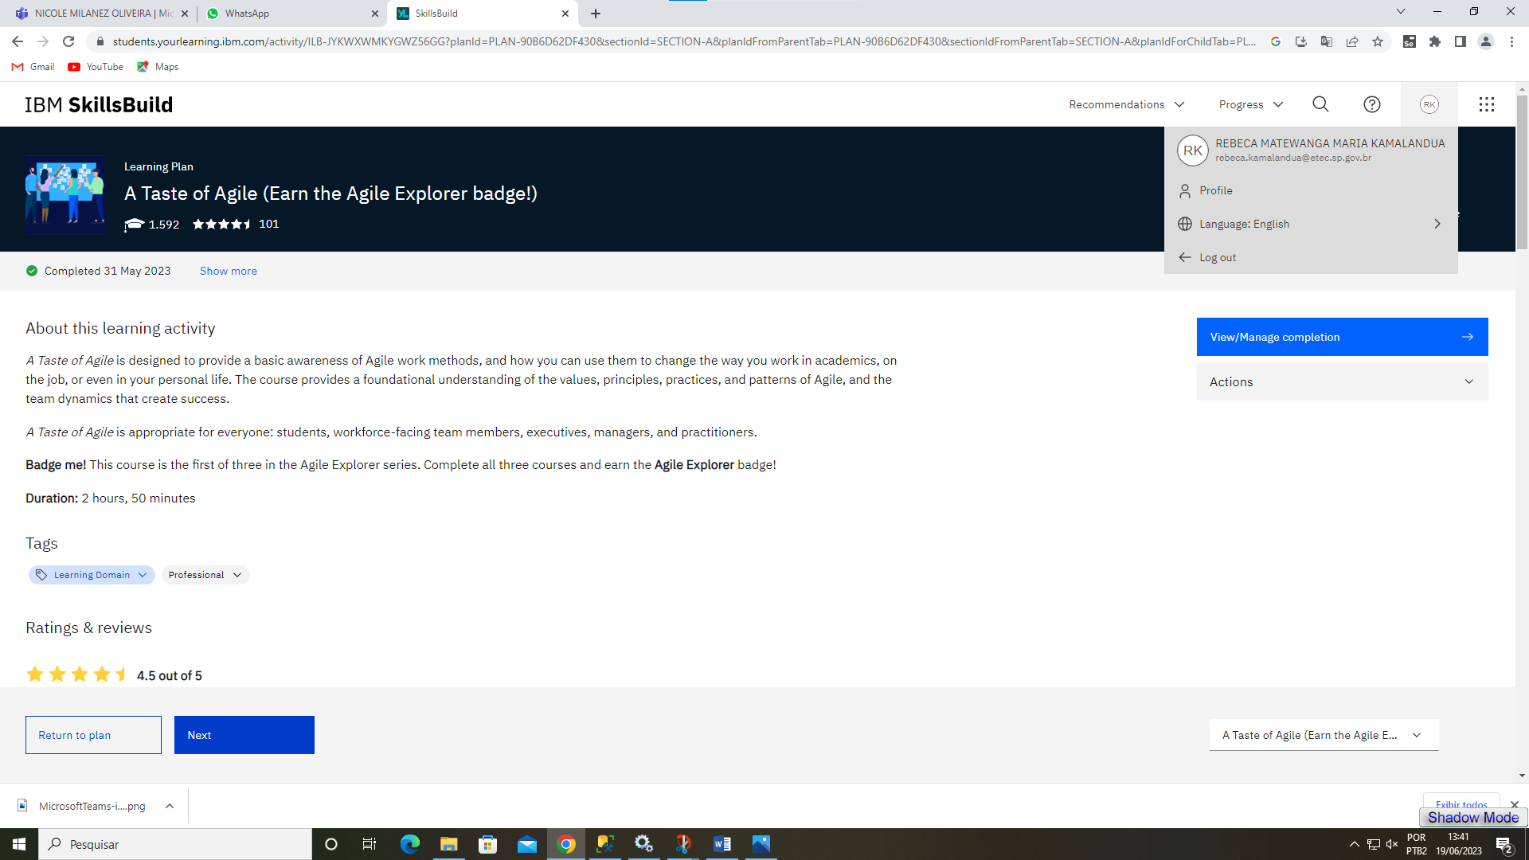A Taste of Agile (Earn the Agile Explorer badge!)

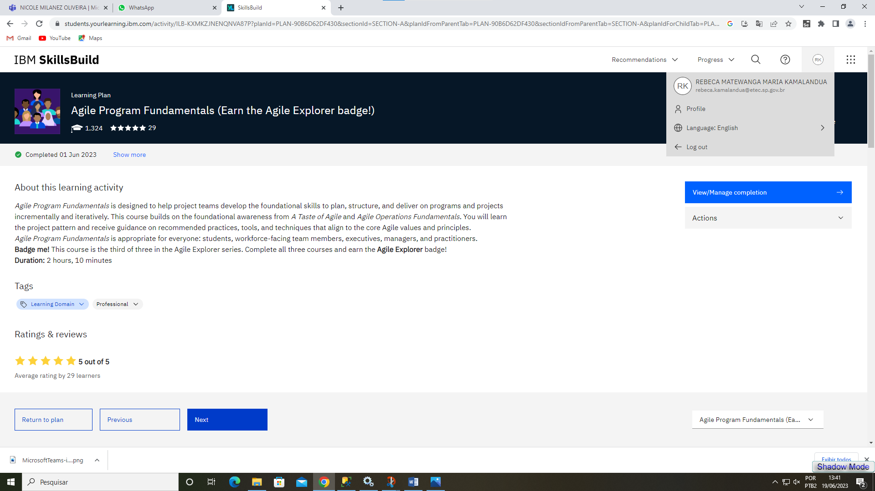Agile Program Fundamentals (Earn the Agile Explorer badge!)

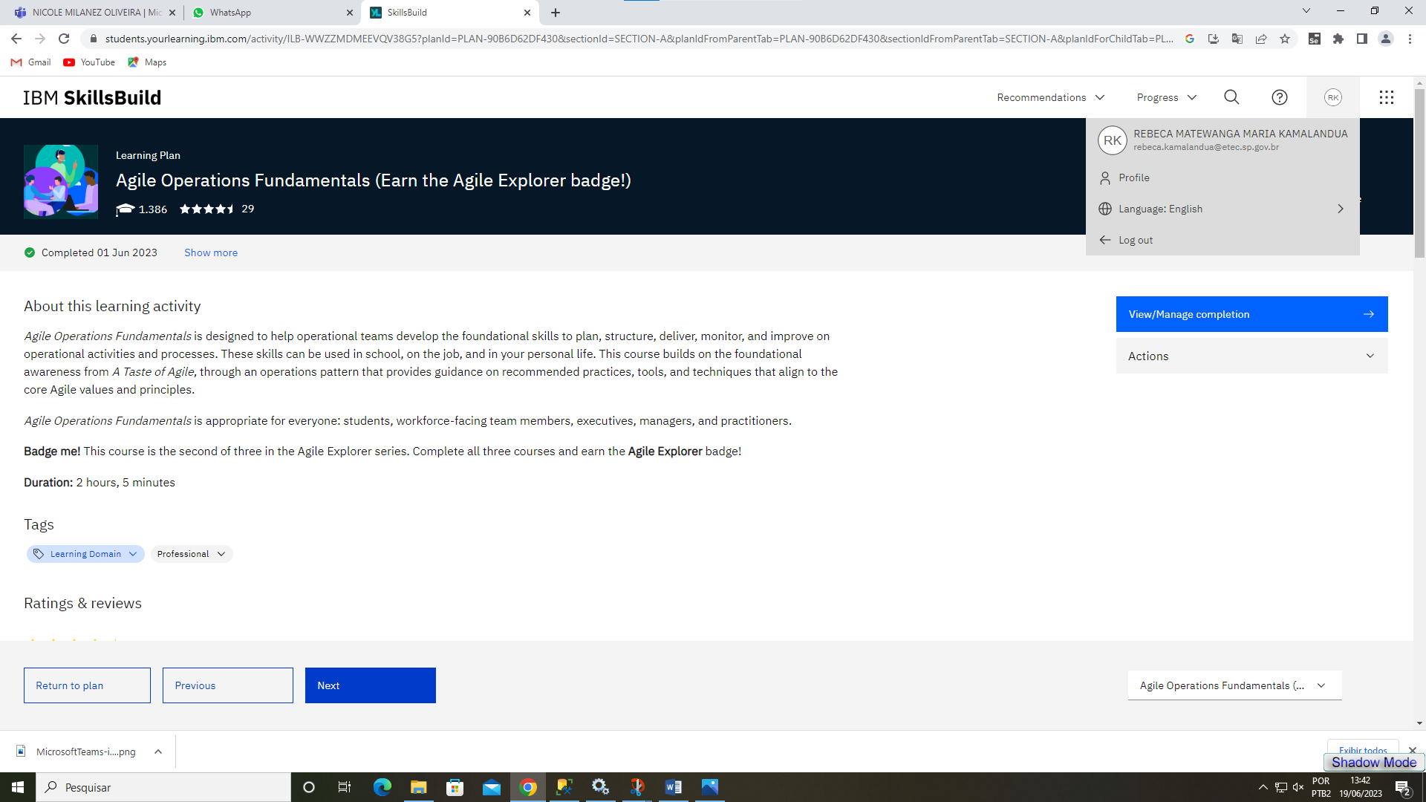Agile Operations Fundamentals (Earn the Agile Explorer badge!)

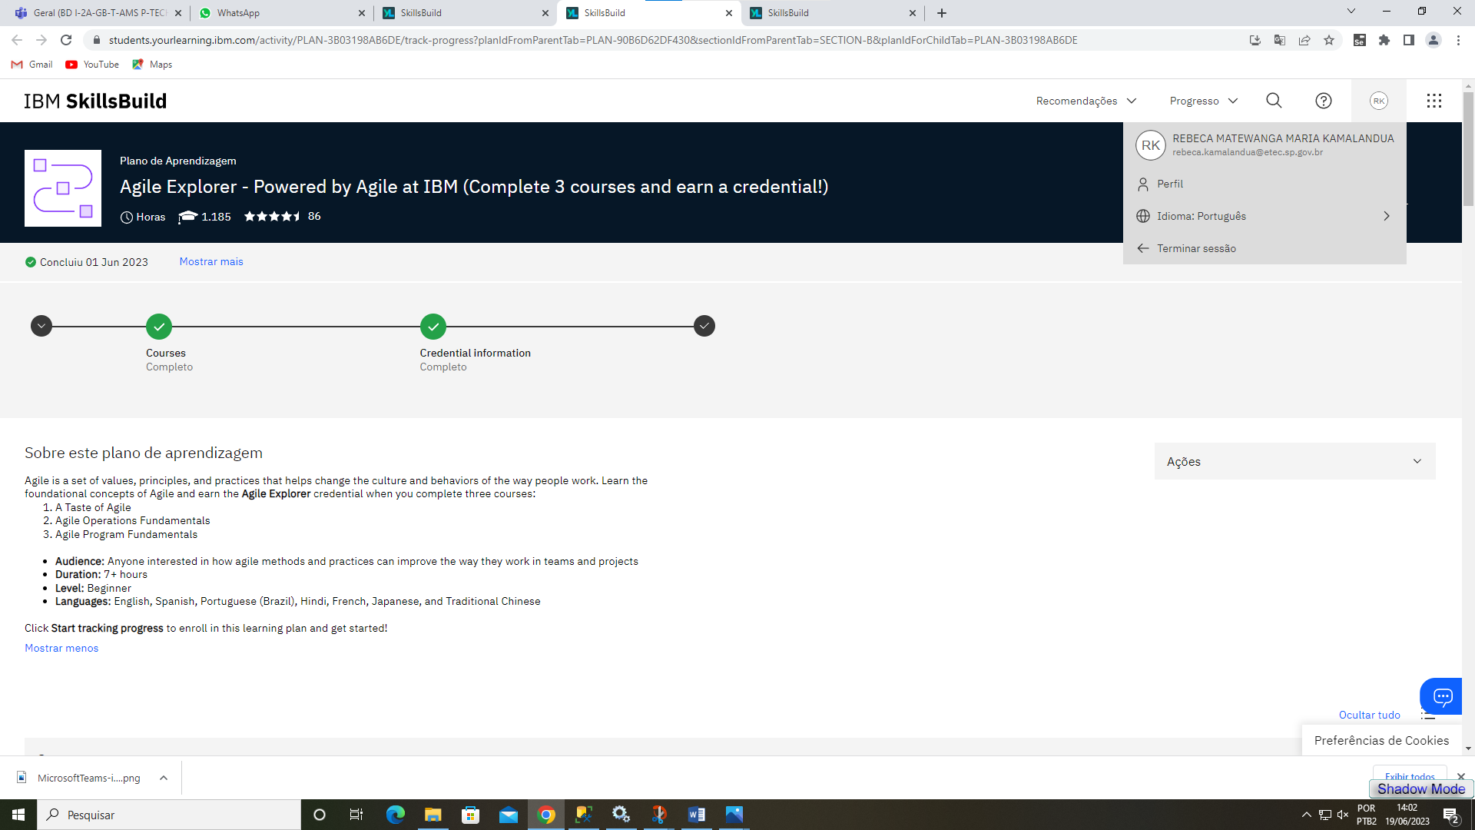Agile Explorer - Powered by Agile at IBM (Complete 3 courses and earn a credential!)

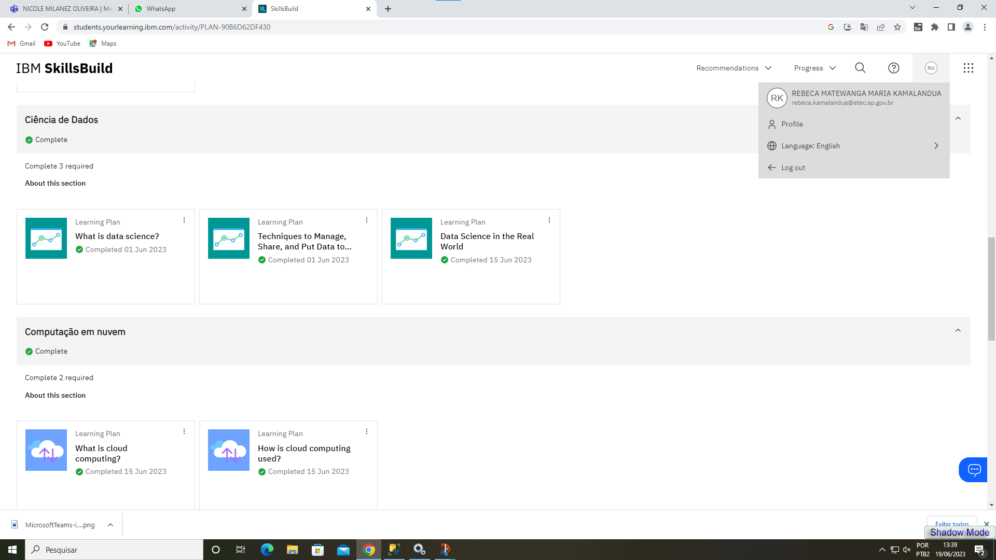Cursos ciências de dados e computação em Nuvem

What is data science?

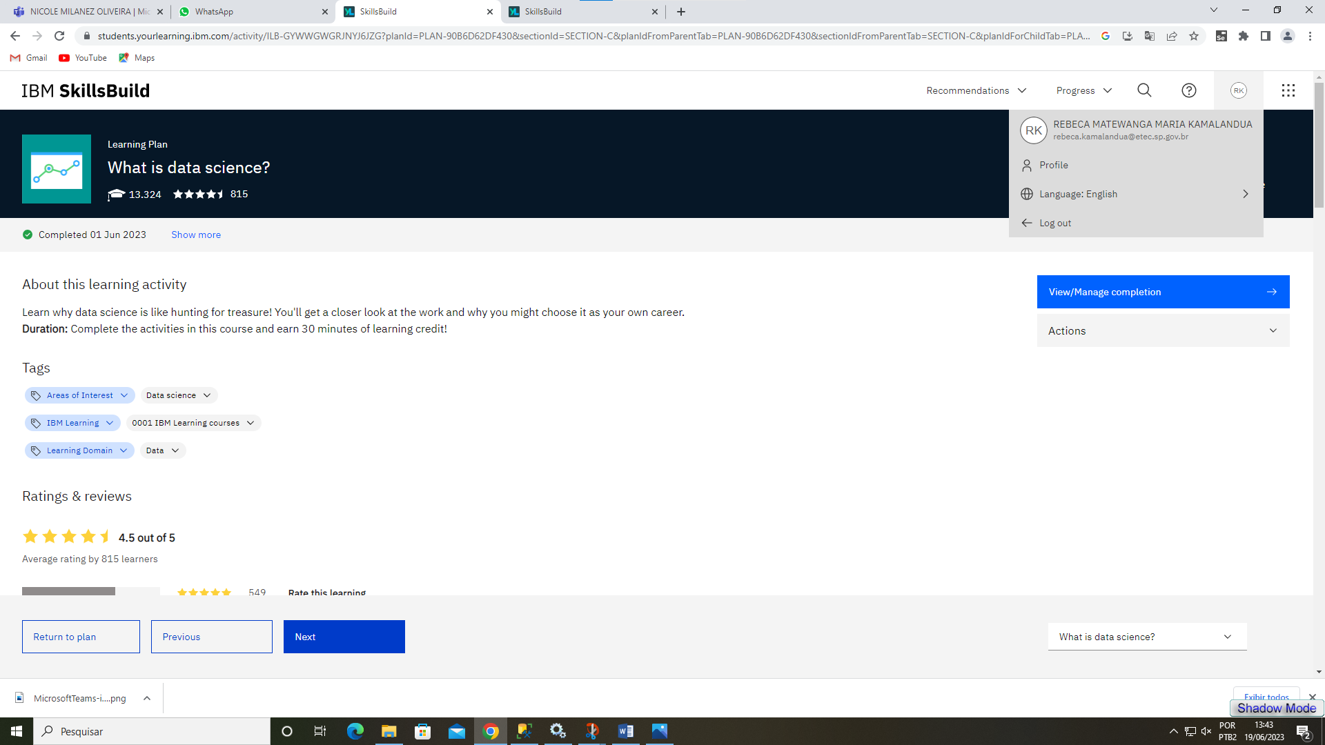

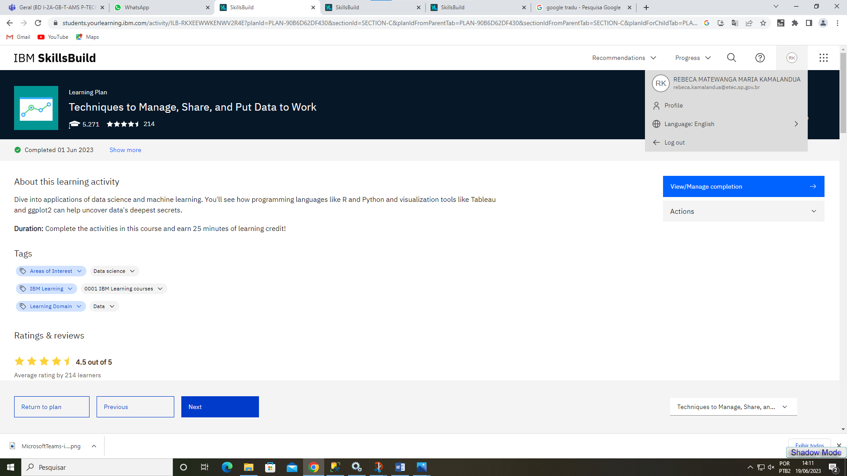Techniques to Manage, Share, and Put Data to Work

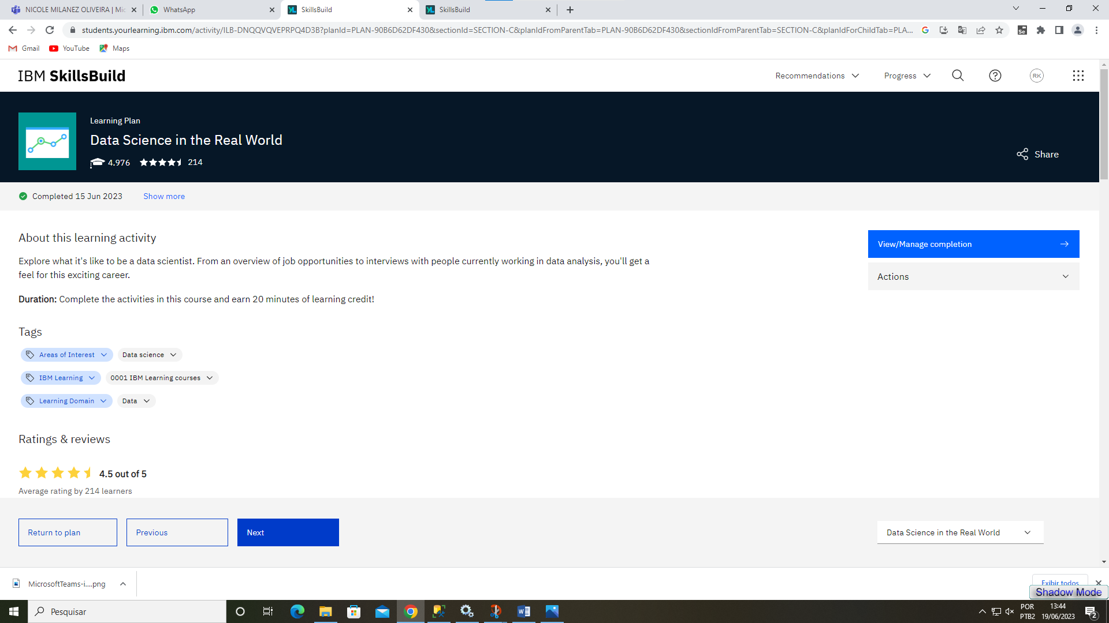Data Science in the Real World

What is cloud computing?

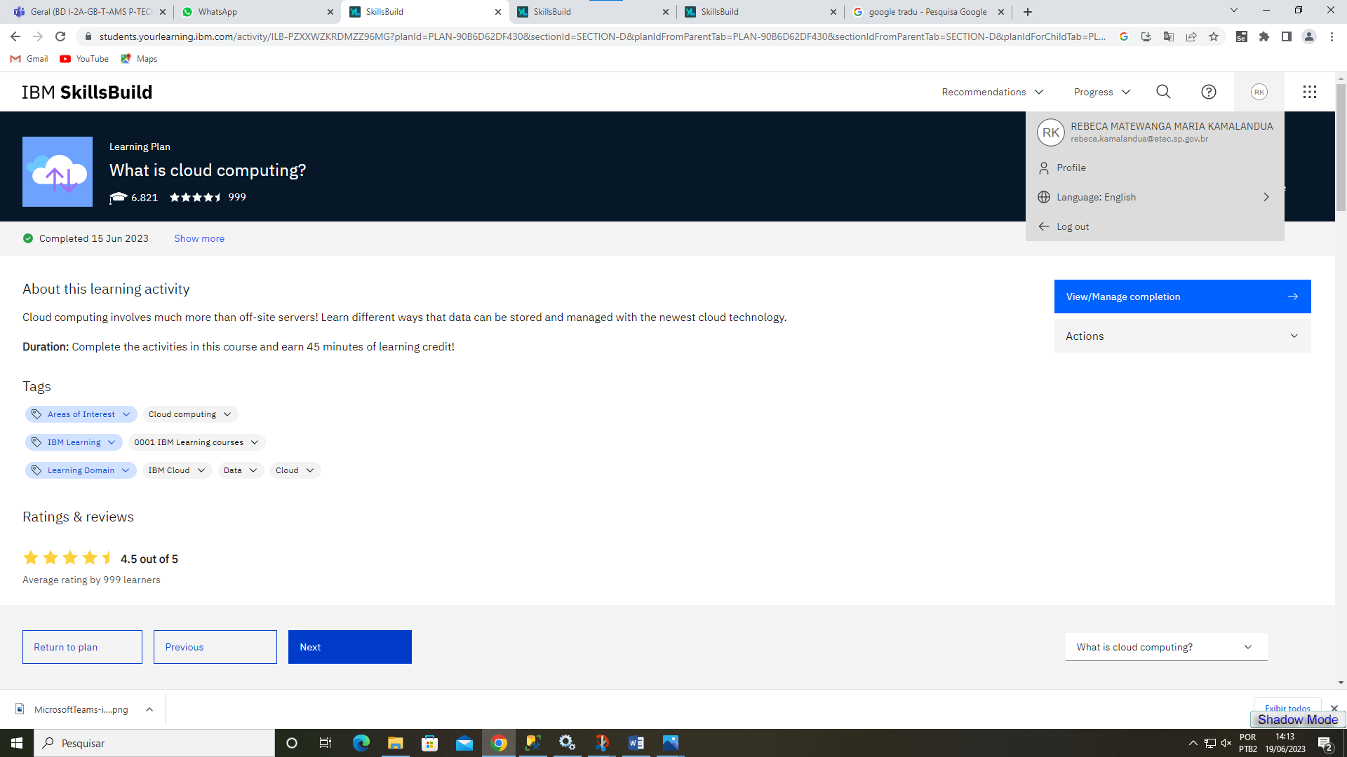

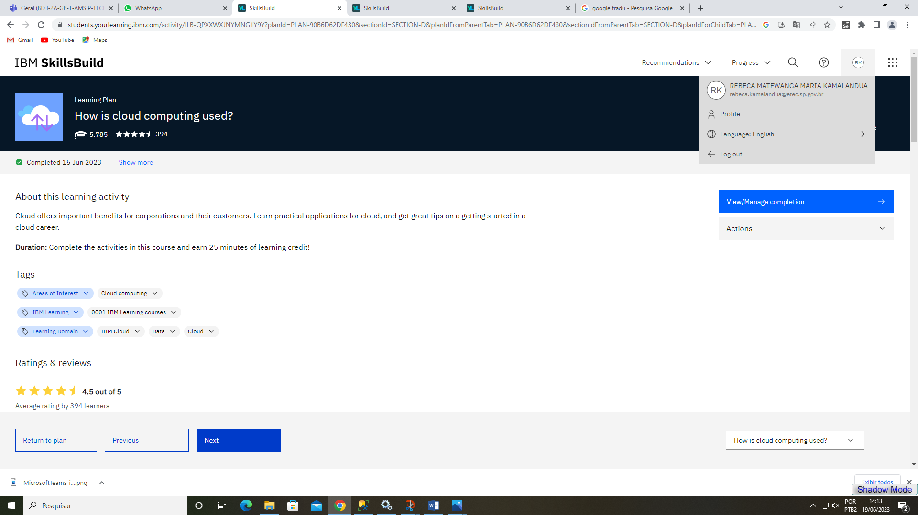How is cloud computing used?

Curso Atenção Plena

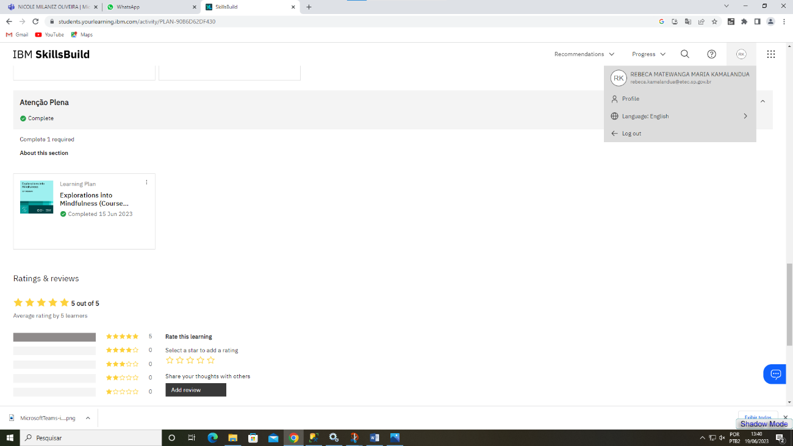

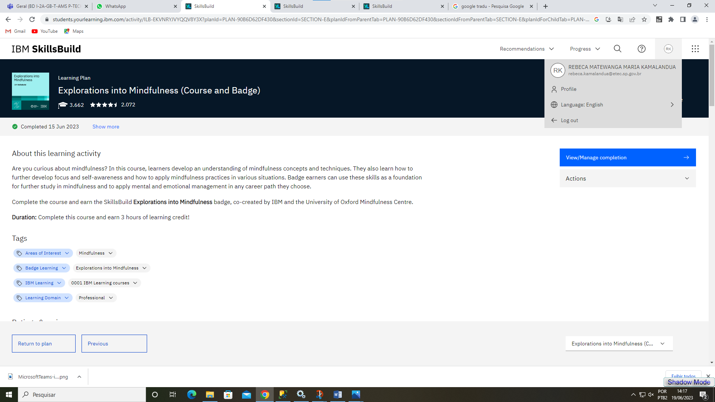Explorations into Mindfulness (Course and Badge)

**Horas Atribuidas**

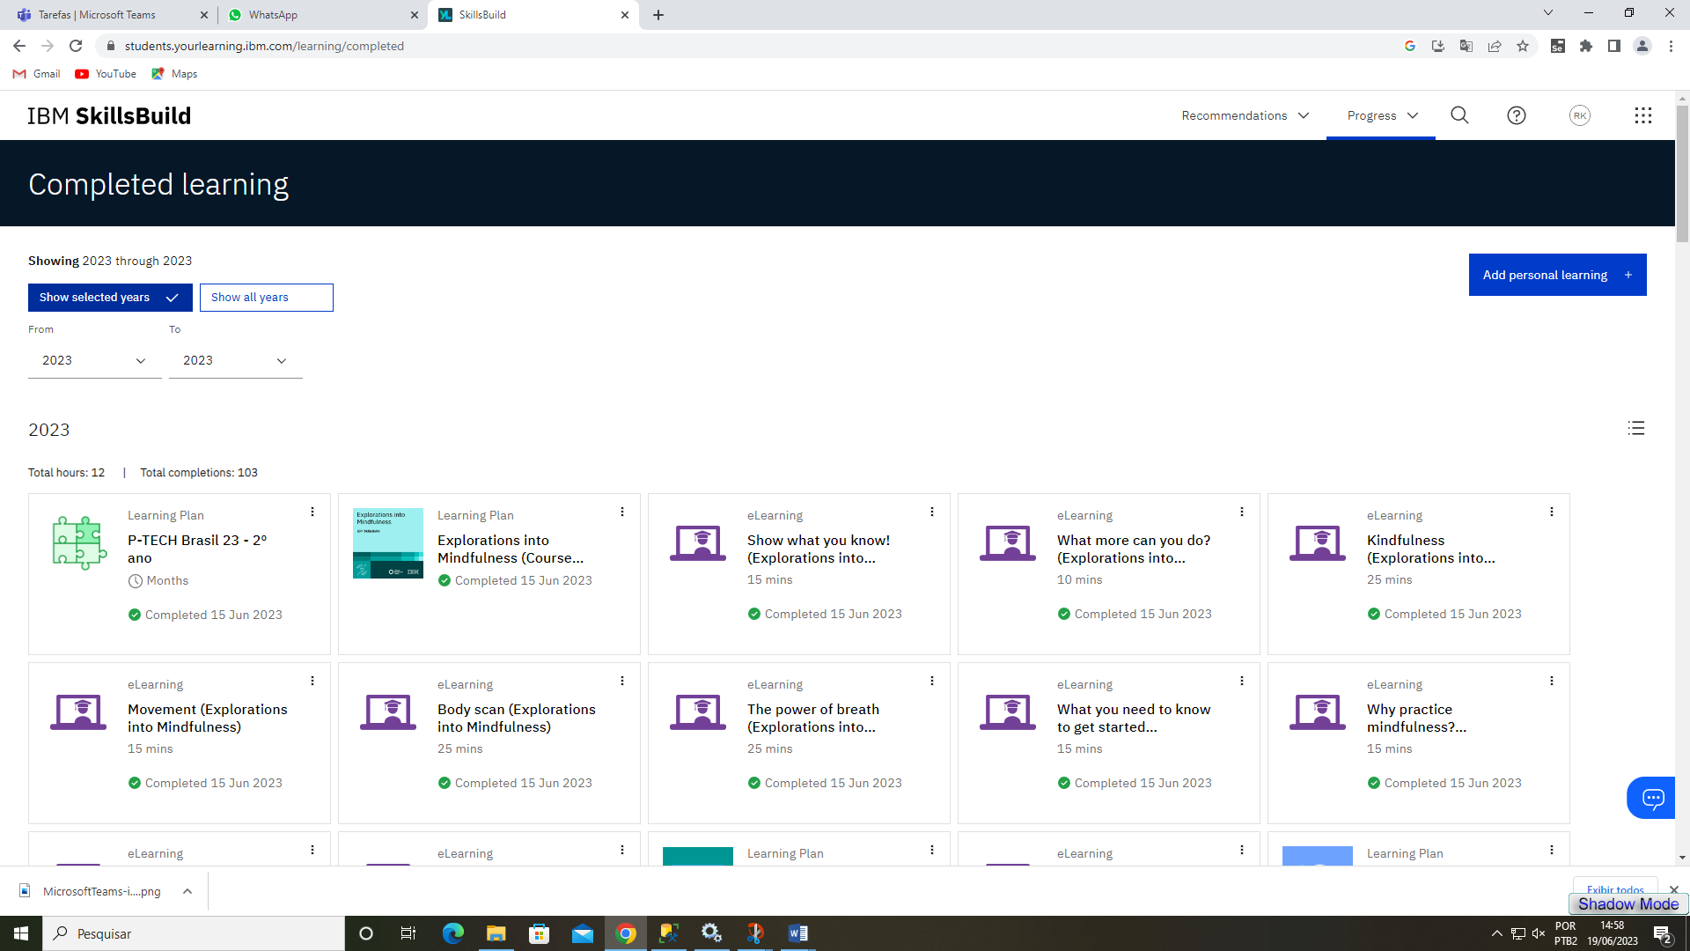

**12 Horas**